Investigation into the Effectiveness of Arrays of Slots Radiating through Truncated Waveguides to Combat Formation of Second-Order Lobes



Queensland University of Technology
School of Electrical Engineering & Robotics

Research Project 2
EGH490-2

Student: Chabod Masere
Supervisor: Dr Jacob Coetzee

A project delivery report submitted in partial fulfilment of the requirements of the Honours unit, Research Project 2 (EGH490-2).

Investigation into the effectiveness of an array of slots radiating through truncated waveguides

Chabod Masere1
1School of Electrical Engineering and Robotics, QUT
-------------------------------------------------------------------------***----------------------------------------------------------------------
Abstract—This paper presents the investigation of the effectiveness of slot arrays radiating through truncated waveguides, with design and development confirming the effectiveness of suppressing second-order lobes in planar slotted waveguide antenna arrays.

design and development of the effectiveness of slot arrays radiating through truncated waveguides as a method for suppressing second-order lobes in planar slotted waveguide antenna arrays.

self-reconfigurable micro robots intended for unpredictable tasks. The clusters of these robots can take any shape based on the defined mission. The cube-shaped robot developed by the researchers of MIT, named M-blocks, can exert forward and backward torques, about three orthogonal axes, in a total of six directions. The single cubic robot can employ pivoting motion, can roll across the surface and can join to other cubic robots. Controlling this M-block is difficult, and the independent movement of the block at a given position is extremely complex, the shape cube is not feasible for moving the block. The tri-bot is introduced, featuring a spherical ball connected to two diamond-shaped arms with pointed edges, each with an electromagnet on its face. The tri-bot can attach to other tri-bots through the provided structure. It can move independently with the tire arrangement on the sphere. A novel magnetic system enables neighbour tri-bot identification using Machine Learning algorithms to guide the autonomous figure, making the robot more intelligent with more data. This design empowers the robot to move easily and complete unpredictable tasks.

Keywords: Second-Order Lobes,

INTRODUCTION

OBOTS have become the part of our day to day life in the form of various devices, designed particularly for the assigned task, the modular robots M-blocks was introduced a decade ago by the MIT researcher that aims at increasing the utilization of robots by modularizing their architecture. Many robotic systems have been designed and proposed that can change their configuration and perform the task at hand. to create robotic systems capable of autonomously changing shape in order to match the system’s structure to the task at hand [1]. These 50mm cubes are autonomous robots that have no external actuated moving parts, and no tethers. The modules realize pivoting using inertial force actuation. A flywheel located inside the module, (oriented in the plane of the intended motion), is used to store angular momentum before a braking mechanism is used to decelerate the flywheel and, during a short duration, exert a high torque on the module. If this torque is sufficiently high, the
R
module breaks its magnetic bonds with
its neighbours and pivots into a new location. An individual module can move autonomously in an unstructured environment using this pivoting (rolling) locomotion. A module can also move on a 3D lattice of identical modules, achieving a desired trajectory on a planar surface or making convex and concave transitions to other planes. The modules can also jump over distances up to several body widths wide. This broad range of motions enables the M-Block system to achieve a wide range of shape changing and locomotion capabilities. [2]. In order to facilitate the implementation of new primitive behaviours, the 3D M-Blocks are further extended in this work to include a novel type of magnetic fiducial which allows modules to detect information about their neighbours. These fiducial tags, called Magnetic Fiducial Tags (MFT), provide globally unique identification codes for each face of a collection of modules. MFTags include relative orientation of the connection between the reading module and the tag being read, and encode information passively, allowing the system to accurately determine its global configuration even when a fraction of modules is either disabled or are passive elements.

For several years, there has been a very noticeable uptick in papers on machine learning applied to robotics and control problems. Reinforced learning techniques seem to be well-suited for some of these tasks (beating a human champion at Go is an impressive feat, and so is winning at Dota 2), but are not without their own issues. Among those are difficulties of choosing a reward function, danger of “reward-hacking” (behaviour that maximizes reward while violating some unmodeled constraints, see [3] for some remarkable examples), and the need for detailed and resource-intensive learning

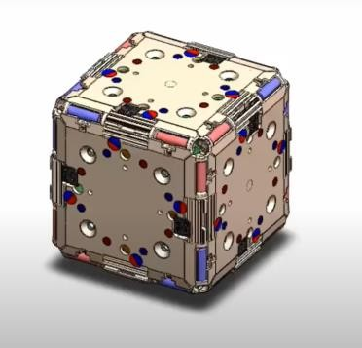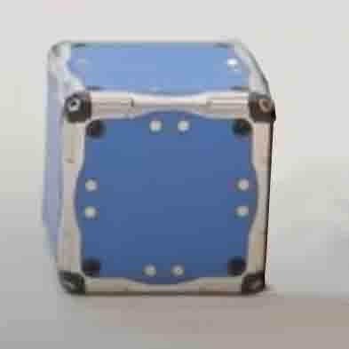
Fig. 1: 3D Design of M-block Fig. 2: Prototype of M-block

The figure 1 shows the 3D design of the M-block 2.0 by the MIT Researchers which has electromagnets on its faces, magnets on the edges, flywheel and actuators in the cube. The figure 2 is the prototype of the M-block. This work focuses on a system of modules that have information only about their direct neighbors, global input from a stimulus source (i.e. visible light), knowledge about gravity, and occasional wireless communication with a higher-level controller. The initial behaviours that introduced Path following and Line formation. The ability for a Modular self- reconfigurable robot system to delegate many of the details of each module’s movements to be autonomously implemented by the individual modules based on local information, while still allowing centralised control, when necessary, improves the system’s ability to scale effectively. While there have been similar proposed decentralised control strategies for modular self-reconfigurable robots.

However, the shape of the cube faces many difficulties for the autonomous moment, the actuator moment, with the
The flying wheel is not accurate enough to get the exact position we intended, so the following design is introduced.

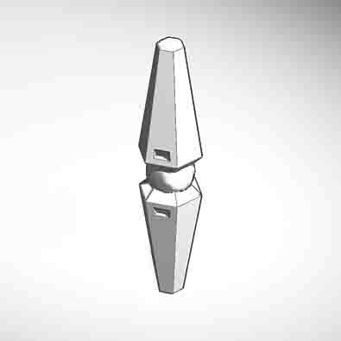

Fig. 3: Structure of Tri-bot
The figure 3 describes the design of the Magnetic Self- reconfigurable robot which has spherical shape supported by the two arms with micro gyro-motor, both the arm and the sphere has electromagnet that can connect to the neighbouring robot and get the specified structure.

RELATED WORK

Till the date, the research is done on the base of the M- block which has the cubic structure. Chain and hybrid systems are typically designed to self-reconfigure using complicated implementations which approximate simpler models, such as the sliding cube model [4] or the pivoting cube model. There have been several systems which attempt to implement the sliding cube model, but these systems have been limited to two dimensions. Additionally, there are systems which are able to self-reconfigure in three dimensions, but these systems all diverge from the simplicity offered by the sliding and pivoting cube mod

